DIGITAL FUEL LEVEL INDICATOR AND RESERVE ALARM

ABSTRACT
Fuel theft and inefficient monitoring are persistent challenges in transportation, fleet operations, and industries dependent on fuel-powered equipment. Traditional methods such as manual gauges or routine inspections are inaccurate, prone to manipulation, and fail to provide timely alerts. To address these issues, this paper presents a Digital Fuel Level Indicator and Reserve Alarm System based on IoT, GSM communication, and the ESP32 microcontroller. The system utilizes an ultrasonic sensor mounted on the top of the fuel tank to continuously measure the distance to the fuel surface and calculate the fuel level. The readings are processed by the ESP32, which distinguishes between normal fuel consumption patterns and abnormal drops caused by theft, leakage, or unauthorized usage.
Whenever the fuel content reaches a predetermined reserve point or a sudden decrease is detected, the ESP32 activates the GSM module to send SMS alerts to the registered user. Simultaneously, fuel level information is transmitted to an IoT cloud dashboard for real-time monitoring, historical data logging, and trend analysis. This remote accessibility improves decision-making and enhances operational efficiency by providing accurate and transparent fuel usage data. An LCD display is also included to provide local, on-site fuel status information.
Experimental testing demonstrates that the system is capable of precise detection of fuel variability, stable cloud connectivity, and reliable alert generation. The solution is cost-effective, scalable, and easy to install, making it suitable for diverse applications such as vehicles, generators, and industrial tanks. By automating fuel monitoring and offering proactive theft detection, the proposed system significantly reduces financial losses, improves security, and supports smarter fuel management practices.
Keywords— Fuel Theft Detection, Digital Fuel Indicator, ESP32, Ultrasonic Sensor, GSM Communication, IoT Monitoring, Real-Time Fuel Level, Embedded Systems, Cloud Dashboard.

CHAPTER 2
INTRODUCTION
Fuel is one of the most valuable and widely consumed resources in transportation, logistics, and industrial operations. However, fuel theft, leakage, and inefficient monitoring have become significant problems that lead to economic losses and operational disruptions. Traditional fuel monitoring methods, such as manual inspections and mechanical gauges, are often inaccurate, prone to manipulation, and lack the ability to provide timely alerts. To overcome these limitations, the proposed project introduces a Digital Fuel Level Indicator and Reserve Alarm System that combines IoT technology, GSM communication, and an ESP32 microcontroller to provide reliable, automated, and real-time fuel management.
The system is designed around an ultrasonic sensor mounted on the top of a fuel tank, which measures the distance between the sensor and the fuel surface. These readings are processed by the ESP32 microcontroller, which converts them into precise fuel level data. The microcontroller constantly monitors normal consumption patterns and identifies sudden changes in the fuel level. Any abrupt decrease is treated as a possible indication of theft, leakage, or unauthorized use of fuel. Additionally, when the fuel level reaches a critical reserve threshold, the system triggers an alert.
To ensure timely notification, the ESP32 activates a GSM module that sends an SMS message to the registered user’s mobile device. This makes sure the user is aware of any abnormal activity, even when they are away from the vehicle or equipment. At the same time, the system transmits the fuel level data to an IoT cloud dashboard, which enables remote monitoring through smartphones or computers. This cloud-based integration not only provides real-time visualization but also stores historical data for trend analysis, decision-making, and improved operational efficiency.
A local LCD display is included to provide on-site monitoring of the fuel status, allowing operators to instantly view whether the fuel level is normal, in reserve, or dropping unexpectedly. The system architecture is simple, scalable, and supported by a regulated power supply to ensure stable operation across all components.
Experimental validation of the system demonstrates its accuracy in measuring fuel levels, reliability in detecting abnormal variations, and stability in transmitting data to the cloud. By combining local monitoring with remote accessibility, the system provides a complete solution for fuel management.
The proposed Digital Fuel Level Indicator and Reserve Alarm System is cost-effective, easy to install, and requires minimal maintenance. Its flexibility allows it to be applied in vehicles, generators, and industrial fuel tanks, making it a practical solution across various sectors. Most importantly, it reduces economic losses caused by fuel theft, improves accountability in fuel usage, and enhances security. By automating fuel monitoring and introducing smart theft detection mechanisms, this project contributes to more transparent and efficient fuel management practices.

1.1 INTRODUCTION
Fuel is one of the most essential resources in modern life, powering vehicles, generators, and a wide range of industrial machinery. With the growing dependence on fuel, its proper management has become a critical challenge in both developed and developing economies. Fuel theft, unauthorized usage, and leakage account for substantial losses every year in the transportation industry, logistics operations, and even in small-scale fuel-dependent applications. Apart from economic losses, these issues also reduce operational efficiency, increase downtime, and create security risks.
Traditionally, fuel monitoring has been carried out using manual gauges or periodic inspections, where an operator physically checks the fuel level. While this approach has been in practice for decades, it is highly inefficient and often inaccurate. Manual readings are prone to human error and can be manipulated, making them unreliable in environments where accountability and transparency are necessary. Similarly, mechanical gauges provide only a rough estimate of fuel levels without offering any data logging, real-time notifications, or theft detection features. As industries are moving toward smart automation, relying on such outdated methods poses serious challenges.
The introduction of embedded systems, IoT (Internet of Things), and cloud-based platforms has opened new opportunities for developing smart fuel monitoring systems. By combining sensors, microcontrollers, and wireless communication technologies, it is now possible to monitor fuel levels with high precision and provide real-time alerts to users. This technological advancement not only ensures better resource utilization but also helps in cutting down losses by detecting thefts and leakages promptly.
The Digital Fuel Level Indicator and Reserve Alarm System is designed as a solution to these issues. Using an ESP32 microcontroller, ultrasonic sensor, GSM communication, and IoT cloud integration, the system continuously monitors fuel levels, identifies unusual consumption patterns, and alerts the user in case of abnormalities. The proposed solution is cost-effective, scalable, and easy to implement in vehicles, generators, and industrial fuel tanks. With its ability to provide local and remote monitoring, the system significantly enhances fuel security, operational efficiency, and decision-making in fuel management.

CHAPTER 3
SYSTEM ANALYSIS

3.1 EXISTING SYSTEM
In most practical cases today, fuel monitoring is still managed by traditional methods. Vehicles and fuel tanks are often equipped with manual dipsticks or float-type gauges, which provide an approximate reading of the fuel level. Operators physically inspect these readings and log them for recordkeeping. While such systems are low-cost and easy to use, they come with several limitations. First, they are highly vulnerable to tampering, which means they cannot reliably prevent or detect theft. Second, these systems only provide information when manually checked, meaning there is no real-time monitoring or automated alert system.
Some advanced fleets and industries use digital gauges that display the fuel level electronically. While this improves visibility, they are still local systems and do not offer remote monitoring or data storage. In many cases, even these electronic gauges are not precise enough to detect small changes in fuel levels, such as gradual leakages or partial thefts. Moreover, these systems often lack integration with communication technologies such as GSM or cloud-based IoT platforms, which means users cannot access fuel data remotely or receive timely alerts.
Another common limitation of existing systems is their inability to store historical data. Without proper data logging, operators cannot analyze fuel consumption trends or identify irregularities over time. This makes it difficult to differentiate between legitimate fuel usage and unauthorized activity. Furthermore, industries relying on fuel for critical operations often suffer from delayed responses to theft or leakage, resulting in increased costs and reduced productivity.
Although there are commercially available fuel monitoring solutions in the market, many of them are expensive, require complex installation, or are not scalable for smaller applications like individual vehicles or small-scale generators. As a result, there is a need for a simple, affordable, and effective system that bridges these gaps by offering real-time monitoring, theft detection, alert notifications, and cloud integration in a user-friendly design.

DISADVANTAGES
- Manual Dependency
- No Real-Time Monitoring
- Tampering Risk
- Limited Accuracy
- No Remote Access
- Lack of Historical Data
- Delayed Response
- Complex Installation
- Scalability Issues

3.2 PROPOSED SYSTEM
The Digital Fuel Level Indicator and Reserve Alarm System is proposed as an innovative solution to overcome the drawbacks of traditional monitoring methods. This system leverages IoT, GSM communication, and embedded systems to provide an automated, real-time, and highly reliable fuel monitoring process. The central unit of the system is the ESP32 microcontroller, which collects data from an ultrasonic sensor placed on the fuel tank. The sensor measures the distance between the fuel surface and the top of the tank, translating this measurement into accurate fuel levels.
Unlike existing systems, the proposed solution does more than just display the fuel level. The ESP32 processes the sensor readings to identify patterns of normal consumption and detect abnormal drops, which may indicate theft, leakage, or unauthorized usage. Once such a situation is identified, the system instantly triggers the GSM module to send an SMS notification to the registered user, ensuring that they are immediately aware of the situation regardless of their location.
To further enhance its usability, the system integrates with an IoT cloud platform. This allows fuel data to be uploaded in real-time, providing remote access via smartphones or computers. The cloud dashboard not only displays the current fuel level but also maintains a record of historical data, enabling users to analyze consumption trends and make informed decisions about fuel usage. A local LCD display is also included to provide on-site monitoring, ensuring that users can check the fuel status directly at the tank.
The system is designed to be cost-effective, scalable, and easy to install. It requires minimal maintenance and can be deployed across different applications such as vehicles, industrial tanks, and power generators.
By automating the process of fuel monitoring and integrating theft detection and reserve alarms, this system significantly improves fuel security, operational efficiency, and accountability.
ADVANTAGES
- Real-Time Monitoring
- High Accuracy
- Theft & Leakage Detection
- Instant Alerts via GSM
- Remote Access
- Dual Display Option
- Scalable Design
- Improved Security & Accountability
- Operational Efficiency

CHAPTER 4
SYSTEM REQUIREMENTS
4.1 HARDWARE REQUIREMENT
PROCESS : INTEL® CORE™ I9-14900K 3.20 GHZ
RAM : 16 GB
HARD DISK : 1 TB
Ultrasonic sensor
LCD
IOT
SMS / GCM
MICROCONTROLLER ESP32
4.1.1 HARDWARE DESCRIPTION
PROCESSOR : INTEL® CORE™ I9-14900K 3.20 GHZ

The Intel® Core™ i9-14900K processor with a base clock speed of 3.20 GHz is a powerhouse in terms of computational capabilities. Designed for intensive workloads, it offers exceptional multi-core performance, making it ideal for tasks like gaming, video editing, 3D rendering, and other processor-intensive applications. Its high clock speed and modern architecture ensure efficient data processing, quick task execution, and minimal latency.
RAM
With 16 GB of RAM, the system provides ample memory for seamless multitasking. This capacity supports the smooth operation of modern software, gaming, and professional applications like video editing tools or machine learning frameworks. It ensures that switching between applications remains fluid, without system slowdowns.
HARD DISK
The 1 TB hard disk offers a significant amount of storage space to accommodate the operating system, essential software, media files, and other data. While traditional hard drives provide large storage capacities, combining this with an SSD can greatly enhance system performance, particularly in boot times and file transfers.
ULTRASONIC SENSOR:
An ultrasonic sensor is a device that uses sound waves to measure the distance to an object. It emits an ultrasonic pulse and measures the time it takes for the pulse to reflect back from the object. By calculating the time delay, it determines the distance between the sensor and the object.
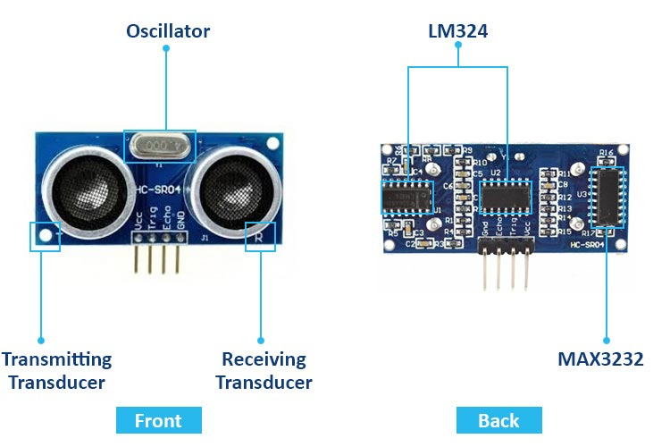
1. WORKING PRINCIPLE OF ULTRASONIC SENSOR
An ultrasonic sensor works by emitting high-frequency sound waves, typically beyond the range of human hearing, and measuring the time it takes for these waves to travel to an object and bounce back. The sensor consists of a transmitter that sends out an ultrasonic pulse and a receiver that detects the reflected sound waves. When the sensor emits the sound wave, it travels through the air until it encounters an object, which reflects the wave back to the sensor. The sensor measures the time it takes for the sound to travel to the object and return. Using the speed of sound in air, the sensor calculates the distance to the object. The formula used is:
Distance = Speed of Sound×Time
2

The factor of 2 accounts for the round trip of the sound wave. By processing the time and the known speed of sound, the sensor can determine the precise distance between itself and the object. This non-contact measurement method makes ultrasonic sensors valuable in a wide range of applications, such as obstacle detection, distance measurement, and level sensing.
2. PIN CONFIGURATION OF ULTRASONIC SENSOR
A common ultrasonic sensor is the HC-SR04. Below is its typical pin configuration:
VCC | Power supply pin (typically +5V).
Trig (Trigger): | Sends a 10 µs HIGH pulse to start the ultrasonic wave.
Echo | Outputs a HIGH signal with duration proportional to the return time of the wave.
GND | Ground pin for the sensor.

3. SPECIFICATIONS OF ULTRASONIC SENSORS
Operating Voltage: 5V DC
Max Current Consumption: ~15 mA during normal operation (up to 50 mA during transmission)
Operating Frequency: 40 kHz
Range: 2 cm to 400 cm (0.02 m to 4 m)
Accuracy: ±3 mm
Resolution: 1 cm (0.01 m)
Beam Angle: About 15 degrees
Response Time: Around 10 ms
Output Type: Digital (Echo pin outputs a HIGH signal, the pulse width corresponds to distance)
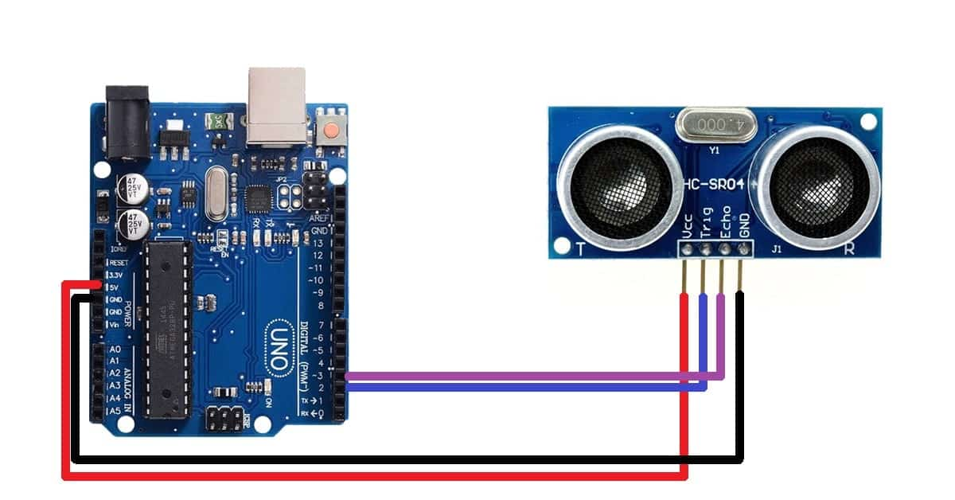
4. APPLICATIONS OF ULTRASONIC SENSORS
- Robotics: Used in robots for obstacle detection, mapping surroundings, and navigation.
- Automotive: In parking sensors for distance measuring to prevent collisions.
- Industrial Automation: For distance measurement in conveyor belts, material handling, and robotic arms.
- Water Level Measurement: Used in tanks, wells, and reservoirs to monitor water levels.
- Gesture Recognition: Detecting hand or body gestures in interactive systems.
- Medical: Ultrasonic sensors are used in medical devices for measurements and imaging, like in ultrasound imaging.
- Security Systems: For motion detection or perimeter monitoring.
ESP32MICROCONTROLLER
The ESP32 is an exceptionally versatile and powerful microcontroller designed for a wide range of Internet of Things (IoT) applications. Developed by Espressif Systems, it integrates advanced features, including built-in Wi-Fi and Bluetooth capabilities, which facilitate seamless connectivity to the internet and other devices. At its core, the ESP32 is powered by a dual-core Tensilica LX6 processor, capable of running at speeds up to 240 MHz, enabling it to handle multiple tasks simultaneously. This makes it suitable for complex applications that require significant processing power, such as real-time data analytics and control systems.
With 520 KB of SRAM and the ability to support external SPI flash memory of up to 16 MB, the ESP32 can accommodate extensive programming and data logging requirements. Its rich set of peripherals includes up to 34 programmable GPIO pins, ADC (Analog-to-Digital Converters) with 12-bit resolution, and DAC (Digital-to-Analog Converters) for generating audio signals or other analog outputs. The presence of various communication protocols, such as SPI, I2C, and UART, allows for easy integration with a multitude of sensors and devices, enhancing its applicability across various projects.
Power management is another strength of the ESP32, featuring several power-saving modes that are particularly beneficial for battery-operated devices. These modes allow the microcontroller to enter deep sleep states, significantly reducing power consumption when the device is idle. Furthermore, robust security features, including hardware encryption (AES, SHA-2), secure boot, and flash encryption, ensure secure communication and data integrity, which are essential for many IoT applications where data security is paramount.
The ESP32 is widely supported by various development environments, including the Arduino IDE and Espressif’s own IoT Development Framework (ESP-IDF), which provide extensive libraries and examples to accelerate the development process. Its applications span diverse fields, from smart home devices that automate lighting and security systems to wearable technology for fitness tracking and health monitoring. The microcontroller is also used in environmental monitoring systems that measure temperature, humidity, and air quality, as well as in industrial automation for monitoring equipment performance and controlling automated processes. In the realm of robotics, the ESP32 serves as a central control unit, facilitating wireless communication and sensor integration for complex robotic systems.
In conclusion, the ESP32 stands out as a highly capable and adaptable microcontroller, combining performance, versatility, and extensive connectivity features in a compact package. Its dual-core architecture and comprehensive set of peripherals make it an excellent choice for a wide variety of applications in the ever-expanding field of IoT. Whether for simple hobbyist projects or sophisticated industrial solutions, the ESP32 continues to gain popularity among developers and engineers for its performance, ease of use, and robust feature set, ultimately paving the way for innovative technological advancements in numerous domains.
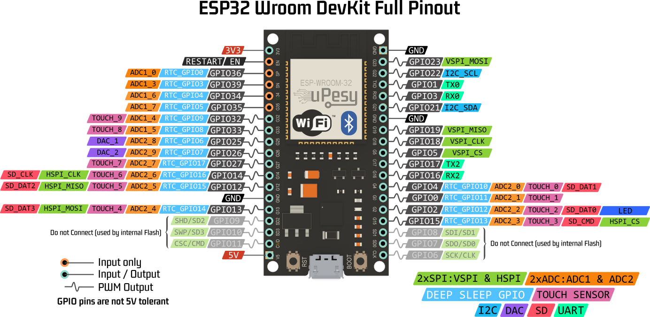
ESP32 PIN FUNCTIONS
- GPIO Pins: Up to 34 configurable General Purpose Input/Output pins for versatile applications. These pins can be programmed for digital input or output, making them suitable for interfacing with a variety of sensors and actuators.
- ADC: Up to 18 channels with 12-bit resolution for accurate analog signal measurement. This feature allows the ESP32 to read varying voltage levels from sensors, providing precise data for applications like environmental monitoring.
- DAC: 2 channels with 8-bit resolution for generating analog outputs. The DAC can be used for audio applications or to control devices that require variable voltage levels.
- Power Pins: V5 for 5V input, V3 for 3.3V output, and multiple GND pins. These power pins facilitate connections to external devices and ensure that the ESP32 operates within its required voltage range.
- I2C Interface: SDA and SCL pins for connecting I2C devices. The I2C protocol allows multiple devices to share the same bus, simplifying the wiring and connections needed for complex projects.
- SPI Interface: Standard pins for MISO, MOSI, SCK, and CS for SPI communication. SPI is a high-speed interface ideal for connecting fast peripherals, such as sensors and memory cards.
- UART Interface: TX and RX pins for serial communication. These pins enable the ESP32 to communicate with other devices over a serial interface, useful for debugging and data transmission.
- Touch Sensor Pins: Configurable pins for touch-sensitive input. This feature allows for the development of user interfaces that can detect touch input, enhancing interactivity in applications.
- RTC Functions: Pins for real-time clock operations and wake-up triggers. These functions are essential for applications requiring time-based operations, even during low power modes.
- Programming/Debugging: EN pin for chip enable and IO0 for boot mode selection during programming. These pins are crucial for loading new firmware and debugging the ESP32 during development.
ESP32 Specifications
- Microprocessor: Dual-core Tensilica LX6 processor with up to 240 MHz clock speed. This architecture allows for efficient handling of multiple tasks simultaneously, making it suitable for demanding applications.
- Memory: 520 KB of SRAM and support for up to 16 MB of external SPI flash memory. The ample memory capacity enables the execution of complex algorithms and the storage of extensive data.
- Wireless Connectivity: Integrated Wi-Fi (IEEE 802.11 b/g/n) and Bluetooth (Classic and BLE). This dual connectivity enhances the flexibility of the ESP32 in IoT applications, allowing seamless communication with various devices.
- GPIO Pins: Up to 34 General Purpose Input/Output pins for various applications. These pins can serve multiple functions, such as analog input, PWM output, or digital signaling, making the ESP32 adaptable to different project needs.
- Analog Features: 12-bit ADC with up to 18 channels and 2 channels of 8-bit DAC. The high-resolution analog features are ideal for applications requiring precise signal measurement and generation.
- Power Supply: Operates within a voltage range of 3.0V to 3.6V. This range allows the ESP32 to be powered by various sources, including batteries and regulated power supplies, enhancing its usability in portable applications.
- Power Management: Multiple power-saving modes, including deep sleep. These modes significantly reduce power consumption, making the ESP32 suitable for battery-operated devices and energy-efficient applications.
- Operating Temperature: Functional range from -40°C to 85°C. This wide temperature range ensures reliable performance in diverse environmental conditions, from industrial applications to outdoor deployments.
- Security Features: Hardware encryption (AES, SHA-2), secure boot, and flash encryption. These security measures help protect sensitive data and ensure the integrity of the device, which is critical in IoT applications.
- Development Support: Compatible with Arduino IDE, Espressif ESP-IDF, and other frameworks. The extensive development support, along with a rich set of libraries and resources, simplifies the programming process and accelerates project development.

LIQUID CRYSTAL DISPLAY
A liquid crystal display (LCD) is a flat panel display, electronic visual display, or video display that uses the light modulating properties of liquid crystals. Liquid crystals do not emit light directly. LCDs are available to display arbitrary images (as in a general-purpose computer display) or fixed images which can be displayed or hidden, such as preset words, digits, and 7-segment displays as in a digital clock. They use the same basic technology, except that arbitrary images are made up of a large number of small pixels, while other displays have larger elements. An LCD is a small low cost display. It is easy to interface with a micro-controller because of an embedded controller (the black blob on the back of the board). This controller is standard across many displays (HD 44780) which means many micro-controllers (including the Arduino) have libraries that make displaying messages as easy as a single line of code.
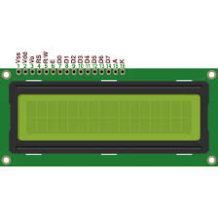
LCD display unit
LCDs are used in a wide range of applications including computer monitors, televisions, instrument panels, aircraft cockpit displays, and signage. They are common in consumer devices such as video players, gaming devices, clocks, watches, calculators, and telephones, and have replaced cathode ray tube (CRT) displays in most applications. They are available in a wider range of screen sizes than CRT and plasma displays, and since they do not use phosphors, they do not suffer image burn-in. LCDs are, however, susceptible to image persistence.

16X2 LCD SPECIFICATIONS
- Display Format: 16 characters per line, 2 lines total.
- Character Size: 5x8 pixels for standard characters.
- Dimensions: Approximately 80mm x 36mm x 13mm.
- Interface: Parallel (4-bit or 8-bit mode).
- Supply Voltage: Typically 5V DC.
- Current Consumption: Around 1.5 mA at 5V.
- Backlight: LED backlight (3.3V to 5V).
- Temperature Range: 0°C to 70°C operating, -20°C to 80°C storage.
- Response Time: Under 10 ms.
- Mounting: PCB or breadboard compatible.
- Character Set: Standard ASCII with custom character support.
I2C (Inter-Integrated Circuit)
The I2C connection for an LCD display enables efficient and simplified interfacing with microcontrollers, like the ESP32, by requiring only two data lines: SDA (data) and SCL (clock). This setup significantly reduces the number of pins needed, compared to traditional parallel connections, allowing other I/O pins on the microcontroller to remain free for additional sensors or peripherals. The I2C interface is controlled by a small I2C module on the back of the LCD, typically using a chip like the PCF8574, which converts the I2C signals into parallel signals the LCD can interpret.
Each device on the I2C bus has a unique address (e.g., 0x27 for many LCD modules), letting the microcontroller communicate with specific devices even if there are multiple I2C components on the same bus. The power (VCC) and ground (GND) lines complete the connections, and the data transfer is synchronous, meaning the microcontroller (master) sends commands in sync with the LCD (slave). Commands like positioning the cursor, clearing the display, or updating text are all handled through simple I2C libraries that streamline programming. This makes I2C ideal for projects that require organized wiring and efficient communication, especially in setups where pin limitations and space are considerations.
IOT
INTERNET OF THINGS
The Internet of Things (IoT) is the network of devices such as vehicles, and home appliances that contain electronics, software, actuators, and connectivity which allows these things to connect, interact and exchange data. The IoT involves extending Internet connectivity beyond standard devices, such as desktops, laptops, smartphones and tablets, to any range of traditionally dumb or non-internet-enabled physical devices and everyday objects. Embedded with technology, these devices can communicate and interact over the Internet, and they can be remotely monitored and controlled.

Fig:1.1 Representation of IoT

The definition of the Internet of things has evolved due to convergence of multiple technologies, real-time analytics, machine learning, commodity sensors, and embedded systems. Traditional fields of embedded systems, wireless sensor networks, control systems, automation (including home and building automation), and others all contribute to enabling the Internet of things.
1.2 HOW IOT WORKS
An IoT ecosystem consists of web-enabled smart devices that use embedded processors, sensors and communication hardware to collect, send and act on data they acquire from their environments. IoT devices share the sensor data they collect by connecting to an IoT gateway or other edge device where data is either sent to the cloud to be analyzed or analyzed locally. Sometimes, these devices communicate with other related devices and act on the information they get from one another. The devices do most of the work without human intervention, although people can interact with the devices -- for instance, to set them up, give them instructions or access the data. The connectivity, networking and communication protocols used with these web-enabled devices largely depend on the specific IoT applications deployed.
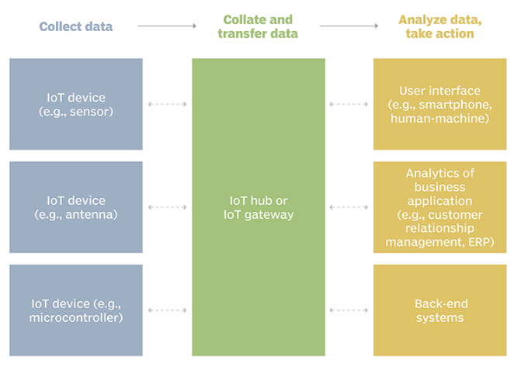
Fig1.2: Example of an IOT system

1.3 BENEFITS OF IOT
The internet of things offers a number of benefits to organizations, enabling them to:
- monitor their overall business processes;
- improve the customer experience;
- save time and money;
- enhance employee productivity;
- integrate and adapt business models;
- make better business decisions; and
- Generate more revenue.
IoT encourages companies to rethink the ways they approach their businesses, industries and markets and gives them the tools to improve their business strategies.

1.4 IOT SECURITY AND PRIVACY ISSUES
The internet of things connects billions of devices to the internet and involves the use of billions of data points, all of which need to be secured. Due to its expanded attack surface, IoT security and IoT privacy are cited as major concerns.
One of the most notorious recent IoT attacks was Mirai, a botnet that infiltrated domain name server provider Dyn and took down many websites for an extended period of time in one of the biggest distributed denial-of-service (DDoS) attacks ever seen. Attackers gained access to the network by exploiting poorly secured IoT devices.
Because IoT devices are closely connected, all a hacker has to do is exploit one vulnerability to manipulate all the data, rendering it unusable. And manufacturers that don't update their devices regularly -- or at all -- leave them vulnerable to cybercriminals.
Additionally, connected devices often ask users to input their personal information, including names, ages, addresses, phone numbers and even social media accounts -- information that's invaluable to hackers.
However, hackers aren't the only threat to the internet of things; privacy is another major concern for IoT users. For instance, companies that make and distribute consumer IoT devices could use those devices to obtain and sell users' personal data.
Beyond leaking personal data, IoT poses a risk to critical infrastructure, including electricity, transportation and financial services.
1.5 IOT APPLICATION AREAS
Near Field Communication (NFC), Radio frequency Identification (RFID), Machine-to-Machine Communication (M2M) & Vehicle-to-Vehicle Communication (V2V) are the technologies by which IoT is being implemented exponentially. It is assumed that more than 50 billion IoT devices will be connected through internet. It is going to change human life, working style, entertaining ways and many more. IoT have many Applications Areas and domain of these application are increasing day by day.
There are ample of applications of IoT as follow:
• Smart Cities
• Building & Home automation
• Environmental Monitoring
• Automotive Industry
• Smart Retail
• Smart Agriculture
• Smart Industry
• Energy Management
• Healthcare Monitoring
EMBEDDED SYSTEM
An embedded system is one kind of a computer system mainly designed to perform several tasks like to access, process, store and also control the data in various electronics-based systems. Embedded systems are a combination of hardware and software where software is usually known as firmware that is embedded into the hardware. One of its most important characteristics of these systems is, it gives the o/p within the time limits. Embedded systems support to make the work more perfect and convenient. So, we frequently use embedded systems in simple and complex devices too. The applications of embedded systems mainly involve in our real life for several devices like microwave, calculators, TV remote control, home security and neighborhood traffic control systems, etc.
An embedded system is integration of hardware and software, the software used in the embedded system is set of instructions which are termed as a program. The microprocessors or microcontrollers used in the hardware circuits of embedded systems are programmed to perform specific tasks by following the set of instructions. These programs are primarily written using any programming software like Proteus or Lab-view using any programming languages such as C or C++ or embedded C. Then, the program is dumped into the microprocessors or microcontrollers that are used in the embedded system circuits.
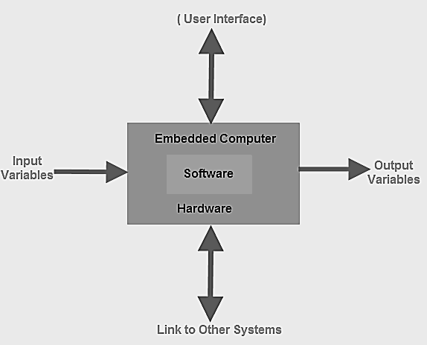

Embedded System Classification
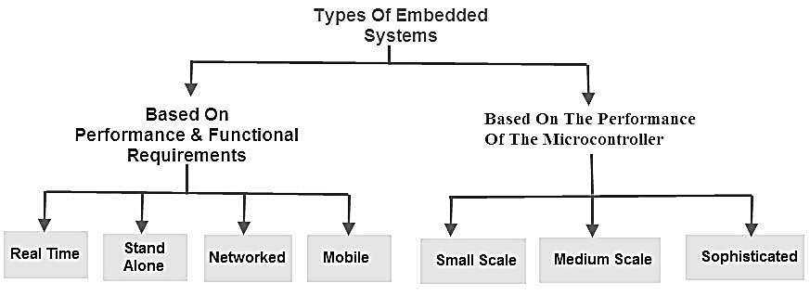
Embedded systems are primarily classified into different types based on complexity of hardware & software and microcontroller (8 or 16 or 32-bit). Thus, based on the performance of the microcontroller, embedded systems are classified into three types such as:
- Small scale embedded systems
- Medium scale embedded systems
- Sophisticated embedded systems
Further, based on performance and functional requirements of the system embedded system classified into four types such as:Real time embedded systems
- Standalone embedded systems
- Networked embedded systems
- Mobile embedded systems

Embedded System Hardware
An embedded system uses a hardware platform to perform the operation. Hardware of the embedded system is assembled with a microprocessor/microcontroller. It has the elements such as input/output interfaces, memory, user interface and the display unit. Generally, an embedded system comprises of the following
- Power Supply
- Memory
- Processor
- Timers
- Output/Output circuits
- Serial communication ports
- SASC (System application specific circuits)

Embedded System Software
The software of an embedded system is written to execute a particular function. It is normally written in a high-level setup and then compiled down to offer code that can be stuck within a non-volatile memory in the hardware. Embedded system software is intended to keep in view of the following three limits
- Convenience of system memory
- Convenience of processor’s speed
- When the embedded system runs constantly, there is a necessity to limit power dissipation for actions like run, stop and wake up.

RTOS (Real Time Operating System)
A system which is essential to finish its task and send its service on time, then only it said to be a real time operating system. RTOS controls the application software and affords a device to allow the processor run. It is responsible for managing the different hardware resources of a personal computer and also host applications which run on the PC.
This operating system is specially designed to run various applications with an exact timing and a huge amount of consistency. Particularly, this can be significant in measurement & industrial automation systems where a delay of a program could cause a safety hazard.

Memory and Processors
The different kinds of processors used in an embedded system include Digital Signal Processor (DSP), microprocessor, RISC processor,microcontroller, ASSP processor, ASIP processor, and ARM processor. The different types of memories of an embedded system are given in the below chart.
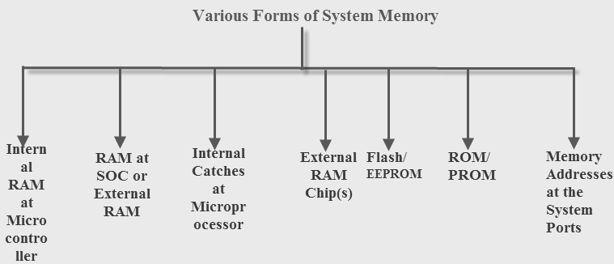

Embedded System Characteristics
- Generally, an embedded system executes a particular operation and does the similar continually. For instance: A pager is constantly functioning as a pager.
- All the computing systems have limitations on design metrics, but those can be especially tight. Design metric is a measure of an execution features like size, power, cost and also performance.
- It must perform fast enough and consume less power to increase battery life.
- Several embedded systems should constantly react to changes in the system and also calculate particular results in real time without any delay. For instance, a car cruise controller; it continuously displays and responds to speed & brake sensors. It must calculate acceleration/de-accelerations frequently in a limited time; a delayed computation can consequence in letdown to control the car.
- It must be based on a microcontroller or microprocessor based.
- It must require a memory, as its software generally inserts in ROM. It does not require any secondary memories in the PC.
- It must need connected peripherals to attach input & output devices.
- An Embedded system is inbuilt with hardware and software where the hardware is used for security and performance and Software is used for more flexibility and features.

Embedded System Applications
The applications of an embedded system basics include smart cards, computer networking, satellites, telecommunications, digital consumer electronics, missiles, etc.
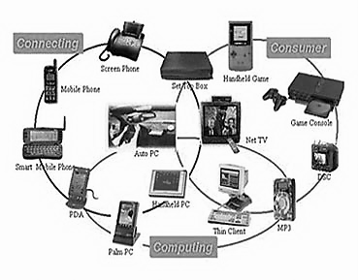
- Embedded systems in automobiles include motor control, cruise control, body safety, engine safety, robotics in an assembly line, car multimedia, car entertainment, E-com access, mobiles etc.
- Embedded systems in telecommunications include networking, mobile computing, and wireless communications, etc.
- Embedded systems in smart cards include banking, telephone and security systems.
- Embedded Systems in satellites and missiles include defense, communication, and aerospace.

SMS/GSM Module
The SMS/GSM module is another integral component of the system, responsible for instant notifications and alerts when abnormal fuel activity is detected. GSM (Global System for Mobile Communication) technology allows the ESP32 microcontroller to communicate with mobile networks, enabling the system to send SMS alerts to registered users regardless of their location. This ensures immediate awareness of any critical situations, such as fuel theft, leakage, or reaching the reserve level.
In the proposed system, the GSM module is connected to the ESP32 via UART communication, allowing the microcontroller to send AT commands that control SMS transmission. When the fuel level falls below a defined threshold or a sudden drop is detected, the ESP32 formats a message containing the relevant information, including device ID, current fuel level, and time of occurrence. This message is sent through the GSM module to the user’s registered mobile number.
The main advantage of the GSM module is reliability. Unlike Wi-Fi-based IoT communication, which requires stable internet connectivity, the GSM module operates through mobile networks, which are widely available and dependable in urban and remote areas. This ensures that users receive real-time alerts even in locations without internet access. The SMS alerts act as a backup to cloud notifications, providing redundancy in the system’s monitoring capabilities.
Furthermore, the GSM module enhances security and accountability. Immediate alerts allow users to take prompt action against potential fuel theft or unauthorized access, minimizing financial losses and operational disruptions. Users can also receive notifications for maintenance reminders, system errors, or battery issues in the devices.
The SMS/GSM module integrates seamlessly with the IoT system, complementing remote monitoring by providing direct, actionable alerts to users’ mobile devices. It is low-power, easy to interface with the ESP32, and supports multiple simultaneous alerts for fleet management applications.
In summary, the SMS/GSM module ensures timely communication and responsiveness, providing an effective mechanism for theft detection, reserve warnings, and overall fuel management. By combining GSM alerts with IoT cloud monitoring, the system achieves both reliability and convenience, making it suitable for vehicles, industrial tanks, and generators where real-time supervision is critical.

4.2 SOFTWARE DESCRIPTION
ARDUINO IDE
The Arduino integrated development environment (IDE) is a cross-platform application (for Windows, macOS, Linux) that is written in the programming language Java. It is used to write and upload programs to Arduino board.
The source code for the IDE is released under the GNU General Public License, version 2. The Arduino IDE supports the languages C and C++ using special rules of code structuring.^{[4]} The Arduino IDE supplies a software library from the Wiring project, which provides many common input and output procedures. User-written code only requires two basic functions, for starting the sketch and the main program loop, that are compiled and linked with a program stub main() into an executable cyclic executive program with the GNU tool chain, also included with the IDE distribution. The Arduino IDE employs the program argued to convert the executable code into a text file in hexadecimal encoding that is loaded into the Arduino board by a loader program in the board's firmware.
Arduino is an open-source electronics platform based on easy-to-use hardware and software. Arduino boards are able to read inputs - light on a sensor, a finger on a button, or a Twitter message - and turn it into an output - activating a motor, turning on an LED, publishing something online. You can tell your board what to do by sending a set of instructions to the microcontroller on the board
ARDUINOIOT CLOUD

Arduino IoT Cloud is a robust and versatile platform that enables users to develop, manage, and deploy Internet of Things (IoT) applications with ease. It is designed to integrate seamlessly with Arduino boards and other compatible hardware, allowing makers, hobbyists, and developers to create connected devices and control them remotely through a straightforward, intuitive interface. By leveraging this platform, users can build projects that gather sensor data, trigger actions, and visualize information in real time from anywhere in the world.One of the defining aspects of Arduino IoT Cloud is its user-friendly design, which lowers the barrier to entry for IoT development. It provides a visual interface where users can create things, define variables, and link devices without extensive coding knowledge. This no-code or low-code approach makes the platform accessible to beginners while still being powerful enough for advanced users who want to dive deep into custom development.The platform supports a wide range of devices, including Arduino boards like the MKR series, Nano 33 IoT, and even third-party boards compatible with the Arduino ecosystem. Users can program these boards directly from the cloud, eliminating the need for a local development environment. The Arduino Web Editor allows coding, compiling, and uploading sketches directly through a web browser, streamlining the development process and making it more flexible.With Arduino IoT Cloud, users can easily create dashboards to monitor and control their devices. These dashboards support various widgets, such as buttons, sliders, gauges, and graphs, to visualize data and interact with connected devices. The drag-and-drop interface for building dashboards means that users can quickly design custom control panels without writing complex front-end code.Security is a core consideration in Arduino IoT Cloud, with features like secure device authentication and data encryption. Devices are linked to the cloud using secure credentials, and communication is encrypted to protect sensitive information. This ensures that users can trust their connected devices to operate safely, even when accessed remotely over public networks.Arduino IoT Cloud integrates with popular services and platforms, allowing users to build complex systems that connect with other web services and APIs. For example, users can set up automation rules to trigger actions based on specific conditions, such as turning on lights when a sensor detects motion or sending an alert when temperature thresholds are exceeded. Integrations with platforms like Amazon Alexa and Google Assistant also enable voice-controlled interactions, adding another layer of convenience.The platform includes extensive documentation, tutorials, and an active community that makes learning and troubleshooting easier. Arduino’s open-source ethos means that users can access and modify source code, contribute to community projects, and share their own creations. This collaborative environment encourages innovation and continuous learning, as users can draw inspiration from one another’s work and build on shared knowledge.One of the key strengths of Arduino IoT Cloud is its scalability. Users can start with simple projects, like controlling an LED or reading data from a temperature sensor, and gradually progress to more complex applications, such as home automation systems, environmental monitoring, or industrial IoT solutions. The platform’s flexible structure and ability to manage multiple devices make it suitable for both small personal projects and larger deployments.The real-time data capabilities of Arduino IoT Cloud are another highlight. Users can monitor live sensor readings, track historical data, and visualize trends over time. This is invaluable for applications that rely on continuous monitoring, such as agriculture, healthcare, and smart cities. By understanding data patterns, users can make informed decisions and optimize their systems for better performance.Setting up an Arduino IoT Cloud project is straightforward. Users need to create an account, add a device, and define variables that represent the data points they want to monitor or control. The platform automatically generates code snippets to handle cloud connectivity, significantly reducing development time. Once the device is online, users can immediately start interacting with it through their custom dashboards or mobile apps.Arduino IoT Cloud also supports mobile access, enabling users to control and monitor their projects from smartphones or tablets. This adds flexibility, as users can receive push notifications, adjust settings, or check system status on the go. The mobile-friendly interface ensures a seamless experience across devices, making remote management convenient and effective.In educational settings, Arduino IoT Cloud serves as a powerful learning tool. It allows students to experiment with IoT concepts, understand real-world applications, and develop problem-solving skills. Teachers can design interactive lessons where students build connected devices, analyze data, and create their own IoT ecosystems. The platform’s simplicity makes it an excellent choice for classrooms, makerspaces, and workshops.The Arduino IoT Cloud subscription model offers a free tier for hobbyists and small projects, along with paid plans for users who need more devices, extended data retention, or additional features. This flexible pricing structure ensures that users only pay for what they need, making the platform accessible to a broad audience.By providing an all-in-one solution for IoT development, Arduino IoT Cloud empowers users to bring their ideas to life. It bridges the gap between hardware and software, making it easier than ever to create connected systems that interact with the physical world. Whether building a smart home, developing a wearable device, or prototyping an industrial solution, Arduino IoT Cloud offers the tools and support needed to succeed in the exciting world of IoT.Arduino IoT Cloud embodies the spirit of innovation and collaboration that defines the Arduino ecosystem. It fosters creativity, encourages experimentation, and helps users turn concepts into reality. With its blend of simplicity, power, and community support, it stands out as an invaluable platform for anyone looking to explore the endless possibilities of the Internet of Things.

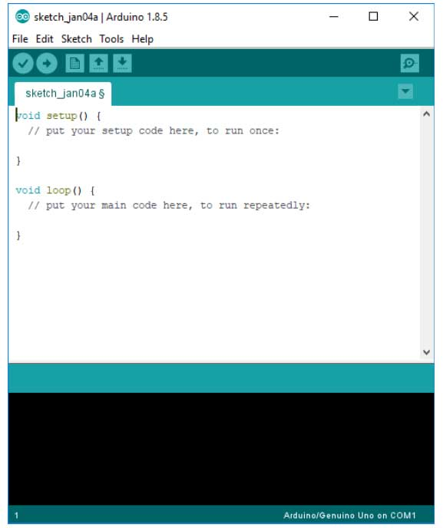

The Arduino IDE
The Arduino IDE is incredibly minimalistic, yet it provides a near-complete environment for most Arduino-based projects. The top menu bar has the standard options, including “File” (new, load save, etc.), “Edit” (font, copy, paste, etc.), “Sketch” (for compiling and programming), “Tools” (useful options for testing projects), and “Help”. The middle section of the IDE is a simple text editor that where you can enter the program code. The bottom section of the IDE is dedicated to an output window that is used to see the status of the compilation, how much memory has been used, any errors that were found in the program, and various other useful messages.
Projects made using the Arduino are called sketches, and such sketches are usually written in a cut-down version of C++ (a number of C++ features are not included). Because programming a microcontroller is somewhat different from programming a computer, there are a number of device-specific libraries (e.g., changing pin modes, output data on pins, reading analog values, and timers). This sometimes confuses users who think Arduino is programmed in an “Arduino language.” However, the Arduino is, in fact, programmed in C++. It just uses unique libraries for the device.
The Arduino Integrated Development Environment - or Arduino Software (IDE) - contains a text editor for writing code, a message area, a text console, a toolbar with buttons for common functions and a series of menus. It connects to the Arduino and Genuine hardware to upload programs and communicate with them.
Programs written using Arduino Software (IDE) are called sketches. These sketches are written in the text editor and are saved with the file extension .ino. The editor has features for cutting/pasting and for searching/replacing text. The message area gives feedback while saving and exporting and also displays errors. The console displays text output by the Arduino Software (IDE), including complete error messages and other information. The bottom right hand corner of the window displays the configured board and serial port. The toolbar buttons allow you to verify and upload programs, create, open, and save sketches, and open the serial monitor.
LIBRARIES
Libraries provide extra functionality for use in sketches, e.g. working with hardware or manipulating data. To use a library in a sketch, select it from the Sketch > Import Library menu. This will insert one or more #include statements at the top of the sketch and compile the library with your sketch. Because libraries are uploaded to the board with your sketch, they increase the amount of space it takes up. If a sketch no longer needs a library, simply delete its #include statements from the top of your code.
There is a list of libraries in the reference. Some libraries are included with the Arduino software. Others can be downloaded from a variety of sources or through the Library Manager. Starting with version 1.0.5 of the IDE, you do can import a library from a zip file and use it in an open sketch.
CONNECTING THE ARDUINO
Connecting an Arduino board to your PC is quite simple. On Windows:
1. Plug in the USB cable - one end to the PC, and one end to the Arduino board.
2. When prompted, select "Browse my computer for driver" and then select the folder to which you extracted your original Arduino IDE download.
3. You may receive an error that the board is not a Microsoft certified device - select “Install anyway.”
4. Your board should now be ready for programming.

When programming your Arduino board it is important to know what COM port the Arduino is using on your PC. On Windows, navigate to Start->Devices and Printers, and look for the Arduino. The COM port will be displayed underneath.
Alternatively, the message telling you that the Arduino has been connected successfully in the lower-left hand corner of your screen usually specifies the COM port is it using.
PREPARING THE BOARD
Before loading any code to your Arduino board, you must first open the IDE. Double click the Arduino .exe file that you downloaded earlier. A blank program, or "sketch," should open.
The Blink example is the easiest way to test any Arduino board. Within the Arduino window, it can be found under File->Examples->Basics->Blink.
Before the code can be uploaded to your board, two important steps are required.
1. Select your Arduino from the list under Tools->Board. The standard board used in RBE 1001, 2001, and 2002 is the Arduino Mega 2560, so select the "Arduino Mega 2560 or Mega ADK" option in the dropdown.
2. Select the communication port, or COM port, by going to Tools->Serial Port.
If you noted the COM port your Arduino board is using, it should be listed in the dropdown menu. If not, your board has not finished installing or needs to be reconnected.
LOADING CODE
The upper left of the Arduino window has two buttons: A checkmark to Verify your code, and a right-facing arrow to Upload it. Press the right arrow button to compile and upload the Blink example to your Arduino board.
The black bar at the bottom of the Arduino window is reserved for messages indicating the success or failure of code uploading. A "Completed Successfully" message should appear once the code is done uploading to your board. If an error message appears instead, check that you selected the correct board and COM port in the Tools menu, and check your physical connections.
If uploaded successfully, the LED on your board should blink on/off once every second. Most Arduino boards have an LED prewired to pin 13.
It is very important that you do not use pins 0 or 1 while loading code. It is recommended that you do not use those pins ever.
Arduino code is loaded over a serial port to the controller. Older models use an FTDI chip which deals with all the USB specifics. Newer models have either a small AVR that mimics the FTDI chip or a built-in USB-to-serial port on the AVR micro-controller itself.

CHAPTER 5
LITERATURE REVIEW
5.1: TITLE: A Fuel level indicator using load cell through an audio feed output and location tracker for visually impaired
AUTHOR: C Aravindan; G Vinoth Kumar; R Arthi; R Abhilash
YEAR: 2022
DESCRIPTION:
Now a day's utilization of vehicles has been extensively increased everywhere around the world that each one of us own certain type of transportation facility. Even middle class /high class visually impaired people own vehicles equipped with drivers face common problems like unaware of the amount of fuel filled, distance travelled and unaware of places they are travelling. The proposed work suggests a solution to solve these problems by fixing a prototype in any vehicle and feeds the information in an audio form. Therefore, any Visually impaired person can keep track of all this information and these data can also be shared with some trusted person to take care of the visually impaired person's safety. The prototype uses the fuel level indicator using a load cell and the output is processed with the CPU and sent to an audio feed, GSM modem with GPS module and LCD display are used as the location tracker and display.

5.2: TITLE: Digital Quantity Calculation in Petrol Tanks through Numeric Fuel Indicator for Motor Cycles
AUTHOR: M. Nagarajapandian; J. Aishwariya; S.K. Gayathri; P. Sivaranjani; M. Yazhini; T. Rajesh
YEAR: 2023
DESCRIPTION:
In day-to-day life, petrol fraudulent activities are faced by people and petrol scam awareness isn't familiar to people. Currently, bikes only have fuel pointer displays that show the level of fuel in the tank rather than a detailed count of how much fuel is present. The proposed model solutes the above problem by calculating the fuel consumption in a fuel tank using water flow sensors and displaying it in digital values using digital meters. The amount of fuel in the tank is displayed in liters using numerical digits (ex:1.2 L). This solution builds the numeric fuel pointer display which indicates the correct measure of fuel regarding liters (L). The main aim of this paper is to minimize the burden of the riders continuously checking the fuel level in the tank helping them know the amount of fuel in tank with maximum accuracy without any physical check. This indicator will be powered by a rechargeable battery and the fuel quantity will be displayed using LCD (Liquid Crystal Display). The fuel amount will be measured using a magnetic type flow sensor working under the principle of the Hall Effect. The Digital Petrol quantity calculator system is easily fixed to the petrol tank of the vehicles externally, such that the proposed system is aware of the safety purpose.

5.3: TITLE: Digital Fuel Monitoring System For Automobiles
AUTHOR: Sakthimohan. M; Elizabeth Rani. G; Pidugu Ramprasad; Challa Venkata Reddy; Boyapati Sai Prasad
YEAR: 2021
DESCRIPTION:
In the existing automobiles, the exact quantity of fuel remaining in the tank is displayed in the digital format, where a sensor and a microprocessor are used to locate the stockpile in an economical and accurate manner. This article focuses on the investigation of several backlog measuring sensors that are appropriate for our purpose. Some of the significance of the existing fuel level measurement techniques are discussed. The proposed tool is helpful for measuring not just gasoline, but also milk, water, and other liquids. Also, the propsoed device can be primarily used in all cars to measure fuel consumption. To indicate the amount of fuel in the tank, this research work has employed two types of sensors in the digital fuel indicator: an ultrasonic sensor and a flow sensor. The Arduino board has been designed by employing ultrasonic sensor and flow sensor to measure the distance and pressure to display the fuel level in liquid crystal display [LCD]. The main components present in the proposed model are:, Arduino UNO board, flow sensor, ultrasonic sensor, liquid crystal display and power supply.

5.4: TITLE: Experimental Study on Fuel Economy of Fuel Cell Truck Under Different Driving Cycle
AUTHOR: Tian Sun; Guang Chen; Hao Lan; Jianqiang Guo; Xiaobing Wang; Dong Hao
YEAR: 2021
DESCRIPTION:
Fuel economy is an important indicator to evaluate vehicle performance as it is directly associated with fuel costs. This paper introduces a method to evaluate the fuel economy of fuel cell vehicles (FCVs). A fuel cell truck (FCT) was tested under a 40 km/h constant speed and a China heavy-duty commercial vehicle test cycle-heavy truck (CHTC-HT) driving cycle scenarios to determine the FCV energy consumption, driving range, and hydrogen emissions in different driving cycles and analyze the influences of these driving cycles on fuel economy evaluation. The test results demonstrated that compared with its performance under the 40 km/h constant speed scenario, when the FCT was tested under the CHTC-HT scenario, the electricity consumption per 100 km and the hydrogen consumption per 100 km were increased by 60.35% and 52.02%, respectively; the driving range was reduced by 43.49%; the hydrogen emission per 100 km rose by 171.17%, and the hydrogen emission rate grew by 26.96%.

5.5: TITLE: Design of Fuel Supply Control System for Automobile Dual Fuel Tanks
AUTHOR: Hongwang Zhao; Caizhong Lan; Yi Liang
YEAR: 2022
DESCRIPTION:
The dual fuel tank can not only meet the needs of long-distance, but also ensure the balance of the vehicle and reduce the fuel sloshing in the fuel tank. This paper presents a design of dual fuel tank oil supply control system for automobile. Firstly, the key components of dual fuel tank are designed and selected. Secondly, the single chip microcomputer module is introduced to intelligently switch the dual fuel tank oil supply, and connect the OBD module of the whole vehicle to better diagnose the fault of fuel tank system, which provides a theoretical basis for subsequent in-depth research and production.

5.6: TITLE: Possibilities of COTS ultrasonic fuel quantity measurement
AUTHOR: Petr Petlach; Michal Dub
YEAR: 2016
DESCRIPTION:
The article deals with possibilities of utilization of modern industrial sensors for aircraft fuel quantity measurement. The purpose of the fuel quantity measurement in aircraft with either stationary or rotary wings is to provide information about the total amount of fuel and fuel variations under all aircraft attitudes and with all types of fuel. In aircraft technology, there are especially two basic methods of fuel quantity measurement used that are based on measurement of fuel level. Both methods are contact measurement methods and the fuel gauge is always in contact with fuel. The older, easier and cheaper method is based on float level sensors. Modern and more precise method is based on capacitance level sensors. The measured fuel level is then converted to volume or weight of the fuel and displayed on a fuel indicator in the cockpit. Both methods have some limitations and for that reason another fuel level measurement methods have been introduced onboard. Our practical experiments deal with possibilities of COTS ultrasonic sensors utilization for fuel gauging inside small aircraft fuel tank. Ultrasonic fuel level measurement is based on reflecting sound energy at an interface of liquid and air. Tested operating conditions include influence of aircraft attitude changes, mechanical forces changes and temperature changes on whole measuring systems. Fuel volume is also measured by reference capacitance fuel gauge during practical experiments. Experimental results lead to error quantification of COTS ultrasonic fluid level measurement and following technical measures to minimization of systematic errors.

5.7: TITLE: Diagnostics of a Ship Diesel Engine by Proxy Indicators of Fuel Combustion
AUTHOR: Oksana S. Markelova; Aleksandra V. Ivanovskaya
YEAR: 2022

DESCRIPTION:
The task of determining the effective power of a ship's internal combustion engine is of primary importance for the fleet in determining the operational reliability and economic performance of the ship's power plant as a whole. However, the reliability of determining the effective power by known methods (using standard measuring instruments for measuring thermal parameters) often does not meet the requirements of regulatory and technical documentation. Therefore, the urgent task is to develop a universal reliable method for determining the relative power. Estimation of the level of load of the main engine of the ship is based on the use of proxy indicators. Thus, the most complete are the characteristics of fuel combustion in cylinders. The exhaust gas temperature characterizes the presence of excess air in the cylinders, the quality of fuel atomization and combustion. It also indirectly characterizes the level of the heat-stressed state of the engine. The article presents an empirical dependence of the load of a diesel engine, obtained on the basis of statistical data determined at a free running of a fishing vessel without towing an object.

5.8: TITLE: Computational Study of the Effect of Increasing the Fuel Injection Pressure Up to 3000 Bar on the Performance of the Diesel Engine and its Gaseous Emissions
AUTHOR: A. Y. Dunin; Nguyen Thin Quynh; L. N. Golubkov
YEAR: 2020
DESCRIPTION:
Fuel injection pressure has a great influence on diesel engine performance and gaseous emissions. The paper presents the results of single-cylinder engine modeling with fuel injection pressure up to 3000 bar. 3D modeling was performed in Fire ESE Diesel. The results show that increasing fuel injection pressure improves the combustion process. With the fuel injection pressure from 1500 to 3000 bar, the NOx volume decreases by 23.2%. However, NOx did not meet the emission level of EURO VI standard. Therefore, it is necessary to use exhaust gas recirculation (EGR) together with ultra-high fuel injection pressure. When using EGR at 27%, the NOx volume reduces by 93% and NOx emissions meet EURO VI standard at all values of fuel injection pressure from 1500 to 3000 bar, without exhaust after-treatment measures. Nevertheless, at 0% EGR break specific fuel consumption (BSFC) increases by 4.9% indicator power decreases by 4.5% and at 27% EGR the BSFC increases by 4.7% and indicator power decreases by 4.1%.

5.9: TITLE: Petrol level indicator with automated audio alert system
AUTHOR: R. Kalidoss; R. Praniha; P. Raveena; C. Revathy
YEAR: 2017
DESCRIPTION:
This paper deals with the process involved in the development of a system for automation of fossil fuel pump for filling a container. Generally, an operator should pay attention to the fluid container to avoid overflow. In this model, no operator is needed for managing the system. Although automatic water level controllers are already obtainable within the market, these controllers are not appropriate for this application, as the electrodes are in direct contact with the liquid. But for the petrochemical which is primarily based liquid where direct contact with electrodes has to be avoided clearly. The author has come upon a unique system for this application using magnetic sensors. The sensors are fastened at nominal locations on the container. A floating magnet glides on the liquid and triggers the magnetic sensors one-by-one relying upon the level of the liquid. This paper is specifically intended for Industrial purposes as of now. Direct contact of level probes with the content/liquid has been scrupulously avoided in this project. It is a `Fit and Forget' kind of system and is free from fluoride and oxidation with Buzzer Indication.

5.10: TITLE: Research on the Interval Estimation of Aircraft Fuel Consumption based on the Data Distribution Characteristics
AUTHOR: Xi Wang; Jingjie Chen
YEAR: 2020
DESCRIPTION:
The interval estimation of aircraft fuel consumption is an important basis for airline system planning and operation decision. In order to solve the problem that the dispersion characteristics of actual payloads, itinerary difference in traditional fuel consumption estimation, and the uncertainty of operating environment and pilot accustomization and other factors are not fully considered, which affects the overall interval estimation results, this paper proposed an aircraft fuel consumption interval estimation method based on data deviation and density distribution under-sampling(US-D-DD). For all itineraries of the same type of aircraft, considering the deviation and density distribution of the data, the relevance vector machine(RVM) is used to establish the aircraft fuel consumption interval estimation model, and the aircraft fuel consumption interval estimation results with a certain level of confidence are obtained. Finally, the comprehensive evaluation index is given, and the results before and after considering the data distribution characteristics are compared. The experimental results show that the method achieves better interval estimation effect and verifies its effectiveness.

CHAPTER 6
PROJECT DESCRIPTION
6.1 DEFINITION OF THE PROBLEM
Fuel is one of the most essential resources for transportation, industrial operations, and power generation. Despite its importance, fuel monitoring in most practical cases is still managed through traditional methods such as dipsticks, float-type gauges, or simple digital displays. These conventional techniques provide only approximate readings and are heavily dependent on manual inspection, making them prone to human error, delays, and manipulation. A major drawback of such systems is their inability to provide real-time monitoring and timely alerts in case of theft, leakage, or abnormal consumption. This often results in significant financial losses and operational inefficiency for both individuals and organizations.
Although some advanced digital gauges exist, they are usually local systems with limited accuracy and lack the ability to integrate with modern communication technologies such as GSM and IoT platforms. Without connectivity, users cannot monitor fuel levels remotely or access historical consumption data. The absence of proper data storage further restricts the possibility of analyzing patterns, detecting irregularities, or planning for efficient fuel management.
Commercially available smart fuel monitoring solutions attempt to address these challenges but are often too costly, complex to install, or unsuitable for small-scale applications such as individual vehicles, agricultural machinery, and portable generators. As a result, industries and individuals continue to face persistent issues of unauthorized fuel usage, inefficient tracking, and delayed responses to critical situations.
Therefore, there is a clear need for an affordable, scalable, and user-friendly solution that bridges these gaps. The problem lies not only in measuring fuel levels but also in ensuring security, reliability, and accessibility of data in real time. An innovative system that integrates accurate sensing, theft detection, GSM-based alerts, and cloud-based data logging can significantly improve fuel accountability, operational efficiency, and long-term cost savings.

6.2 SCOPE OF THE PROJECT
The problem of inefficient and insecure fuel monitoring extends across multiple sectors, from transportation fleets and construction equipment to industrial fuel tanks and backup power generators. Traditional systems, which rely on manual inspection and basic gauges, provide limited accuracy and are highly vulnerable to manipulation. This lack of precision and reliability creates opportunities for fuel theft, leakage, and unauthorized usage—issues that directly impact financial resources, operational efficiency, and productivity. In industries where fuel is a critical input, such as logistics, mining, and agriculture, even small undetected discrepancies can result in major economic losses over time.
The scope of the problem is not limited to large-scale operations alone. Small-scale applications, such as personal vehicles, portable generators, and agricultural pumps, also face challenges in ensuring fuel accountability. Commercially available solutions, while technologically advanced, are often expensive and designed for large fleets, making them impractical for individual or small business use. This leaves a significant gap for cost-effective, scalable systems that can be applied across different contexts.
Furthermore, the absence of real-time monitoring, remote access, and historical data logging makes it nearly impossible to track consumption trends or detect irregularities promptly. In today’s fast-paced and data-driven environment, delayed detection of fuel theft or leakage can cripple operations and reduce overall trust in fuel management systems.
The problem also spans geographical and infrastructural boundaries, as many regions still lack access to advanced monitoring systems due to cost and complexity. Addressing this issue requires an affordable, easy-to-install, and versatile system that can integrate with IoT and GSM technologies. Thus, the scope of the problem covers both large and small industries, individuals, and organizations that depend on fuel as a core resource and seek solutions to improve accountability, security, and efficiency.

CHAPTER 7
ARCHITECTURE DIAGRAM
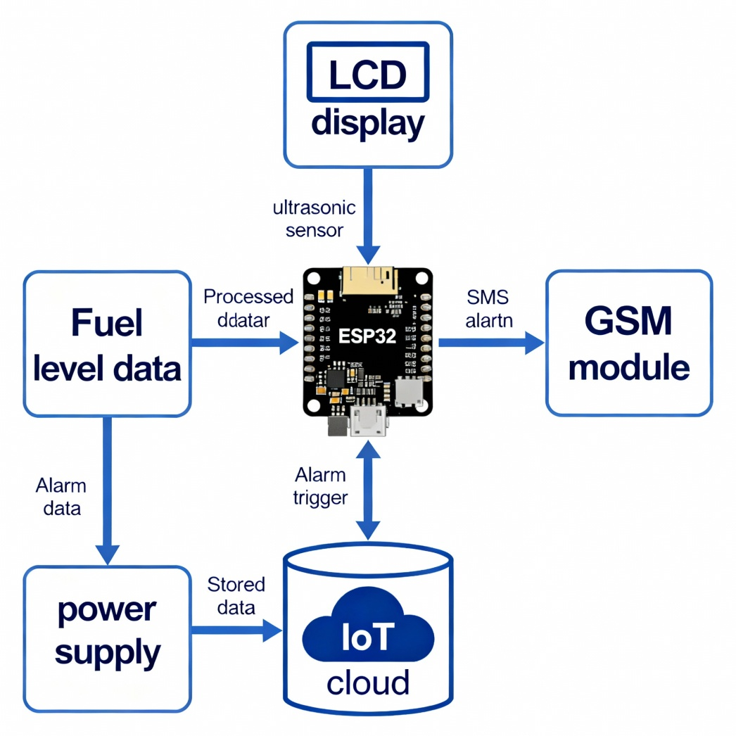
The architecture diagram illustrates the integration of the ESP32 microcontroller with key hardware components for smart fuel monitoring. The ultrasonic sensor reads the fuel level and sends data to the ESP32, which processes this information. The ESP32 simultaneously updates a local LCD, communicates real-time fuel data to an IoT cloud platform, and controls a GSM module to send SMS alerts during fuel theft or reserve conditions. All components receive regulated power from the supply unit, ensuring stable operation. This seamless data flow delivers visible on-site monitoring, remote access, and timely alert generation for reliable and efficient fuel management

DATA FLOW DIAGRAM – LEVEL 0
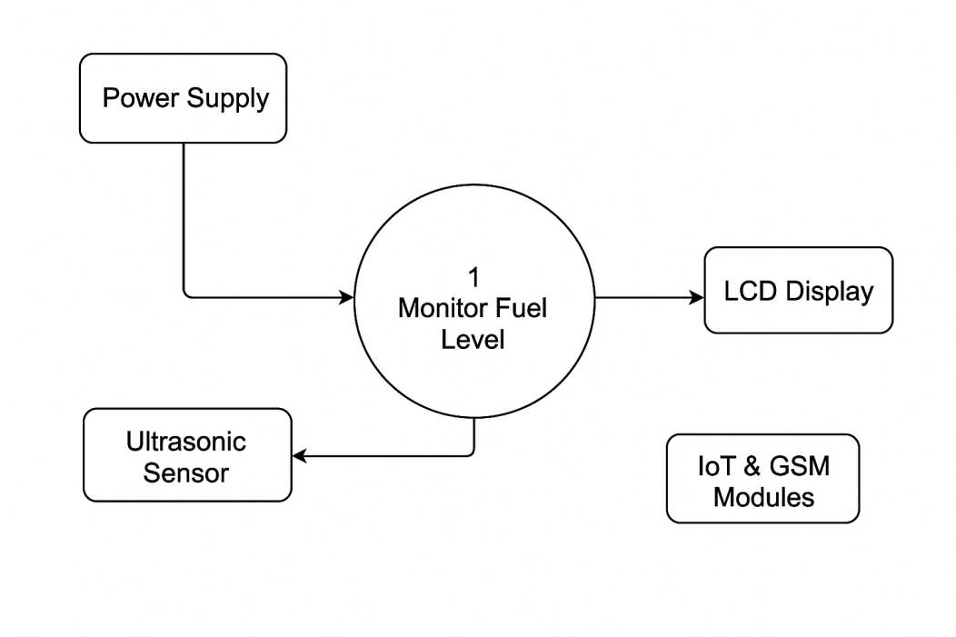

Data Flow Diagram – Level 0 (DFD 0)
The Level 0 Data Flow Diagram represents the high-level overview of the Digital Fuel Level Indicator and Reserve Alarm System. It shows the system as a single process, “Monitor Fuel Level,” which interacts with external entities such as the Power Supply, Ultrasonic Sensor, LCD Display, and IoT/GSM Modules. Input is received from the power unit and ultrasonic sensor, processed by the ESP32 microcontroller, and output is provided through the LCD and IoT/GSM communication modules. This diagram highlights the overall system boundary, showing how external entities exchange data with the central process in a simple, structured manner.
DATA FLOW DIAGRAM – LEVEL 1
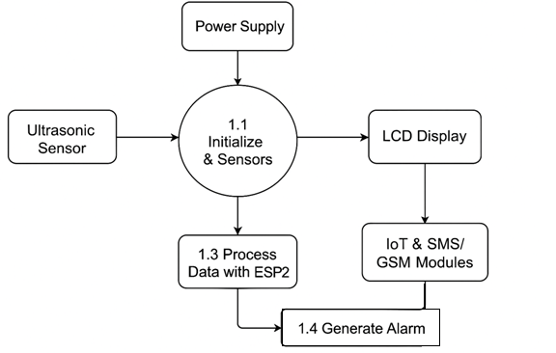

Data Flow Diagram – Level 1 (DFD 1)
The Level 1 Data Flow Diagram breaks down the main process into four detailed sub-processes: Initialize & Sensors, Process Data with ESP32, Generate Alarm, and Update Displays. The ultrasonic sensor provides continuous fuel level readings, which are initialized and passed to the ESP32 for analysis. The ESP32 then checks for abnormalities such as sudden drops or reserve levels. Based on the results, the system either generates an alarm via IoT/GSM modules or updates the LCD and cloud dashboard for real-time monitoring. This decomposition provides a clearer picture of internal data flows and logical operations within the system.
2.2. BLOCK DIAGRAM
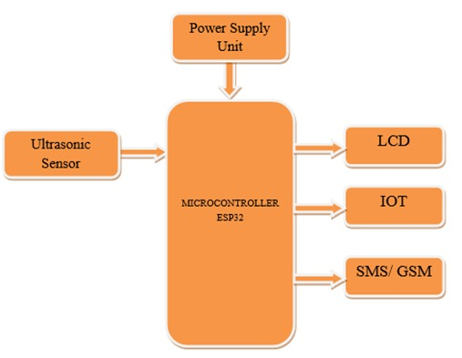

2.3. CIRCUIT DIAGRAM
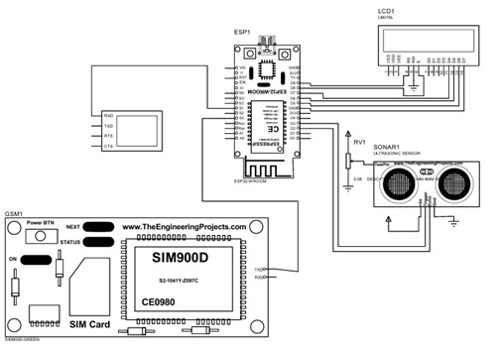
2.4. WORKFLOW DIAGRAM
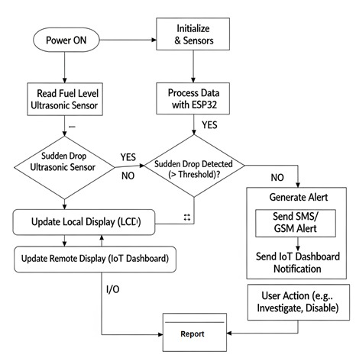

CHAPTER 8
RESULT AND DISCUSSION
The implementation of the Digital Fuel Level Indicator and Reserve Alarm System has demonstrated significant improvements over traditional monitoring methods. The integration of the ESP32 microcontroller with an ultrasonic sensor enabled precise measurement of fuel levels, minimizing inaccuracies commonly observed in float-based gauges or manual dipsticks. The results show that even small variations in fuel levels, such as minor leakages or partial theft, can be detected reliably. This ensures greater accountability in fuel usage and provides operators with real-time visibility into their fuel resources.
One of the key outcomes of the system is the automated alert mechanism. During testing, whenever abnormal fuel drops were simulated, the GSM module successfully triggered SMS notifications to the registered user within seconds. This feature ensures that stakeholders are informed immediately, allowing for quick response to prevent potential losses. The reserve alarm also functioned effectively, notifying users when fuel levels reached a critical threshold, thus preventing unexpected downtime in vehicles or generators.
Another significant result is the successful integration with the IoT cloud platform. The system consistently uploaded real-time fuel data, which could be accessed remotely through smartphones or computers. The cloud dashboard not only displayed the current fuel level but also maintained a historical log. This feature proved particularly useful for analyzing long-term consumption patterns and identifying irregularities. For instance, variations in fuel usage between different shifts of vehicle operation could be clearly observed, providing actionable insights for better fuel management strategies.
The discussion highlights the advantages of scalability and cost-effectiveness. Unlike many commercial solutions that are expensive and require professional installation, this system proved to be simple to set up and adaptable across different applications, including vehicles, industrial tanks, and portable generators. Moreover, its reliance on readily available components makes it affordable without compromising on functionality.
Overall, the results validate that the proposed system effectively bridges the gaps in traditional fuel monitoring. It enhances security by detecting theft, improves efficiency through automation, and strengthens decision-making with accurate data logging and trend analysis. The discussion reinforces that such a system can serve as a practical and scalable solution for both small-scale and large-scale fuel-dependent operations.

CHAPTER 9
CONCLUSION AND FUTURE ENHANCEMENT
9.1 CONCLUSION
The Digital Fuel Level Indicator and Reserve Alarm System presents an effective, reliable, and technologically advanced solution for monitoring fuel levels in vehicles, generators, and industrial tanks. By integrating ultrasonic sensing, ESP32 microcontroller processing, GSM communication, and IoT cloud connectivity, the system provides real-time fuel monitoring, accurate detection of abnormal fuel consumption, and prompt alerts to users, significantly reducing the risks of fuel theft, leakage, and unauthorized usage.
Experimental testing and validation have demonstrated the system’s ability to continuously measure fuel levels, process readings intelligently, and generate timely notifications both locally via LCD display and remotely through SMS and cloud dashboards. The IoT integration enables remote access and historical data analysis, empowering users to make informed decisions, optimize fuel management, and maintain operational efficiency. Additionally, the system’s automated alerts provide an extra layer of security and accountability, ensuring that potential losses are minimized.
One of the key advantages of this system is its scalability and ease of implementation. It can be deployed in a single vehicle, an industrial fuel tank, or a fleet of vehicles without significant modifications, making it versatile and cost-effective. Moreover, by replacing manual fuel monitoring methods, it eliminates human errors and provides precise, actionable information in real time.
In conclusion, the proposed system successfully addresses the limitations of traditional fuel monitoring approaches. It enhances security, improves resource management, and ensures efficient fuel utilization through automation and intelligent monitoring. The combination of IoT technology, GSM alerts, and embedded systems creates a comprehensive solution that is practical, reliable, and adaptable for various real-world applications, ultimately contributing to economic savings and improved operational control.
9.2 FUTURE ENHANCEMENT
While the proposed Digital Fuel Level Indicator and Reserve Alarm System successfully addresses many challenges of traditional fuel monitoring, there is considerable scope for future enhancement to make the system even more robust, intelligent, and versatile. One key direction is the integration of advanced machine learning algorithms to predict fuel consumption patterns based on historical data. Such predictive analytics could help users estimate refueling schedules, detect unusual trends automatically, and optimize operational efficiency.
Another enhancement lies in improving connectivity. Currently, the system relies on GSM communication and cloud integration, but future versions could incorporate advanced communication protocols such as 4G/5G, LoRa, or NB-IoT for faster, more reliable, and wider coverage, particularly in remote or rural areas where GSM networks may be weak. Adding GPS functionality could further strengthen the system by linking fuel usage with vehicle location, helping in route optimization and real-time fleet tracking.
Hardware improvements also present opportunities. The use of multiple sensors, such as pressure-based sensors alongside ultrasonic sensors, could increase accuracy and reduce errors caused by fuel sloshing in moving vehicles. Similarly, adding solar-powered modules could reduce dependency on external power supplies, making the system more sustainable and suitable for off-grid locations.
On the user interface side, mobile and web applications can be enhanced with more interactive dashboards, voice alerts, and multilingual support to improve usability across diverse regions. Furthermore, integration with enterprise resource planning (ERP) systems could enable organizations to directly link fuel monitoring data with their inventory and financial management systems.
In the long term, the system can be scaled into a complete smart fuel management ecosystem that combines monitoring, theft detection, predictive analytics, and operational planning. These enhancements will ensure that the system not only tracks fuel but also becomes a strategic tool for reducing costs, improving security, and driving efficiency across industries.

CHAPTER 10
REFERENCE
- D. Sur, J. Firdaus, R. Dutta, A. Purohit, D. Mitra, and K. Majumder, "IoT based fuel level monitoring and fuel theft detection system," International Journal of Scientific Research in Engineering and Management (IJSREM), vol. 4, no. 2, pp. 1–5, Feb. 2020. [Online]. Available: https://doi.org/10.36375/prepare_u.a87
- R. Bose, S. Roy, S. Chakraborty, and I. Sarkar, "Development of a real-time fuel monitoring system for construction industry using Internet of Things," Journal of Scientific Research and Reports, vol. 30, no. 11, pp. 1064–1070, Nov. 2024. [Online]. Available: https://doi.org/10.9734/jsrr/2024/v30i112633
- B. Anand, K. H. S. Kathyayini, and A. Kumar, "An IoT-based fuel monitoring and tracking system with real-time fuel level detection using accelerometer," Journal of Scientific Research and Reports, vol. 30, no. 11, pp. 1064–1070, Nov. 2024. [Online]. Available: https://doi.org/10.9734/jsrr/2024/v30i112633
- S. Prabhu, D. Kaliyaperumal, and M. Nithya, "IoT enabled fuel level monitoring and automatic fuel theft detection system," in Proc. 13th International Conference on Computing Communication and Networking Technologies (ICCCNT), Bangalore, India, 2022, pp. 1–5. [Online]. Available: https://doi.org/10.1109/ICCCNT54827.2022.9984515
- M. Rakesh, "An IoT-based fuel monitoring and tracking system with real-time fuel level detection using accelerometer," Journal of Scientific Research and Reports, vol. 30, no. 11, pp. 1064–1070, Nov. 2024. https://doi.org/10.9734/jsrr/2024/v30i112633
- B. Anand, K. H. S. Kathyayini, and A. Kumar, "An IoT-based fuel monitoring and tracking system with real-time fuel level detection using accelerometer," Journal of Scientific Research and Reports, vol. 30, no. 11, pp. 1064–1070, Nov. 2024. [Online]. Available: https://doi.org/10.9734/jsrr/2024/v30i112633
- S. Prabhu, D. Kaliyaperumal, and M. Nithya, "IoT enabled fuel level monitoring and automatic fuel theft detection system," in Proc. 13th International Conference on Computing Communication and Networking Technologies (ICCCNT), Bangalore, India, 2022, pp. 1–5. https://doi.org/10.1109/ICCCNT54827.2022.9984515
- M. Rakesh, "An IoT-based fuel monitoring and tracking system with real-time fuel level detection using accelerometer," Journal of Scientific Research and Reports, vol. 30, no. 11, pp. 1064–1070, Nov. 2024. https://doi.org/10.9734/jsrr/2024/v30i112633
- S. Prabhu, D. Kaliyaperumal, and M. Nithya, "IoT enabled fuel level monitoring and automatic fuel theft detection system," in Proc. 13th International Conference on Computing Communication and Networking Technologies (ICCCNT), Bangalore, India, 2022, pp. 1–5. [Online]. Available: https://doi.org/10.1109/ICCCNT54827.2022.9984515
- M. Rakesh, "An IoT-based fuel monitoring and tracking system with real-time fuel level detection using accelerometer," Journal of Scientific Research and Reports, vol. 30, no. 11, pp. 1064–1070, Nov. 2024. https://doi.org/10.9734/jsrr/2024/v30i112633
- S. Prabhu, D. Kaliyaperumal, and M. Nithya, "IoT enabled fuel level monitoring and automatic fuel theft detection system," in Proc. 13th International Conference on Computing Communication and Networking Technologies (ICCCNT), Bangalore, India, 2022, pp. 1–5. [Online]. Available: https://doi.org/10.1109/ICCCNT54827.2022.9984515
- M. Rakesh, "An IoT-based fuel monitoring and tracking system with real-time fuel level detection using accelerometer," Journal of Scientific Research and Reports, vol. 30, no. 11, pp. 1064–1070, Nov. 2024. https://doi.org/10.9734/jsrr/2024/v30i112633
- S. Prabhu, D. Kaliyaperumal, and M. Nithya, "IoT enabled fuel level monitoring and automatic fuel theft detection system," in Proc. 13th International Conference on Computing Communication and Networking Technologies (ICCCNT), Bangalore, India, 2022, pp. 1–5. [Online]. Available: https://doi.org/10.1109/ICCCNT54827.2022.9984515
- M. Rakesh, "An IoT-based fuel monitoring and tracking system with real-time fuel level detection using accelerometer," Journal of Scientific Research and Reports, vol. 30, no. 11, pp. 1064–1070, Nov. 2024. https://doi.org/10.9734/jsrr/2024/v30i112633
- S. Prabhu, D. Kaliyaperumal, and M. Nithya, "IoT enabled fuel level monitoring and automatic fuel theft detection system," in Proc. 13th International Conference on Computing Communication and Networking Technologies (ICCCNT), Bangalore, India, 2022, pp. 1–5. [Online]. Available: https://doi.org/10.1109/ICCCNT54827.2022.9984515
- M. Rakesh, "An IoT-based fuel monitoring and tracking system with real-time fuel level detection using accelerometer," Journal of Scientific Research and Reports, vol. 30, no. 11, pp. 1064–1070, Nov. 2024. https://doi.org/10.9734/jsrr/2024/v30i112633
- S. Prabhu, D. Kaliyaperumal, and M. Nithya, "IoT enabled fuel level monitoring and automatic fuel theft detection system," in Proc. 13th International Conference on Computing Communication and Networking Technologies (ICCCNT), Bangalore, India, 2022, pp. 1–5. [Online]. Available: https://doi.org/10.1109/ICCCNT54827.2022.9984515
- M. Rakesh, "An IoT-based fuel monitoring and tracking system with real-time fuel level detection using accelerometer," Journal of Scientific Research and Reports, vol. 30, no. 11, pp. 1064–1070, Nov. 2024. https://doi.org/10.9734/jsrr/2024/v30i112633
- S. Prabhu, D. Kaliyaperumal, and M. Nithya, "IoT enabled fuel level monitoring and automatic fuel theft detection system," in Proc. 13th International Conference on Computing Communication and Networking Technologies (ICCCNT), Bangalore, India, 2022, pp. 1–5. [Online]. Available: https://doi.org/10.1109/ICCCNT54827.2022.9984515
- M. Rakesh, "An IoT-based fuel monitoring and tracking system with real-time fuel level detection using accelerometer," Journal of Scientific Research and Reports, vol. 30, no. 11, pp. 1064–1070, Nov. 2024. https://doi.org/10.9734/jsrr/2024/v30i112633
- S. Prabhu, D. Kaliyaperumal, and M. Nithya, "IoT enabled fuel level monitoring and automatic fuel theft detection system," in Proc. 13th International Conference on Computing Communication and Networking Technologies (ICCCNT), Bangalore, India, 2022, pp. 1–5. [Online]. Available: https://doi.org/10.1109/ICCCNT54827.2022.9984515
- M. Rakesh, "An IoT-based fuel monitoring and tracking system with real-time fuel level detection using accelerometer," Journal of Scientific Research and Reports, vol. 30, no. 11, pp. 1064–1070, Nov. 2024. https://doi.org/10.9734/jsrr/2024/v30i112633
- S. Prabhu, D. Kaliyaperumal, and M. Nithya, "IoT enabled fuel level monitoring and automatic fuel theft detection system," in Proc. 13th International Conference on Computing Communication and Networking Technologies (ICCCNT), Bangalore, India, 2022, pp. 1–5. [Online]. Available: https://doi.org/10.1109/ICCCNT54827.2022.9984515
- M. Rakesh, "An IoT-based fuel monitoring and tracking system with real-time fuel level detection using accelerometer," Journal of Scientific Research and Reports, vol. 30.

